Course Name: Mobile Applications Development With Flutter

Final Project - Phase 1
المشروع النهائي - المرحلة الأولى
Problem Analysis & Prototype
تحليل المشكلة والنموذج الأولي
Submission Date / تاريخ التسليم: 10/02/2026
Department:[Enter Department]
Batch Representative:[Student Name]
Team ID / رقم الفريق: [T15]

1. Team Information & Project Title
Taiz Hotel
(A Hotel Booking Mobile Application – Starting in Taiz City with Future Expansion Across Yemen)

Team Information
Student Name  اسم الطالب | Role (Dev/Design/Lead)  الدور | Email  البريد الإلكتروني
Nagmi Sadeq Mohmmed Abduljalil | تحليل – تصميم واجهات المستخدم | Nagmisadeqmohmmed@gmail.com

2. Executive Summary /

[This project aims to design a mobile application that helps users find and book hotels in Taiz city easily and efficiently. Currently, hotel searching and booking in Taiz and many Yemeni cities rely on traditional methods such as phone calls or direct visits, which wastes time and often provides unclear or inaccurate information about prices and room availability.
The proposed solution is a mobile application developed using Flutter that allows users to browse hotels, view detailed information such as prices, services, images, and location, and send booking requests directly through the app. The application will initially focus on Taiz city as a pilot area, with a scalable design that allows future expansion to other cities in Yemen. The core value of the app is to simplify the hotel booking process, save users’ time and effort, and support digital transformation in the Yemeni hospitality sector.]

3. Problem Statement & Analysis /

Problem Description:
[Travelers and visitors in Taiz city face difficulties in finding suitable hotels in terms of price, location, and services. Most booking processes depend on direct communication with hotels or informal intermediaries, leading to poor user experience and unreliable information..]
Current Limitations:
- [Lack of a centralized hotel booking application in Taiz
- Dependence on phone calls or in-person visits
- Unclear pricing and room availability
- Difficulty comparing hotels based on services and location]

4. Target Audience Analysis /

Primary Users:
- [Local travelers within Yemen
- Visitors coming to Taiz city
- Age range: 18–55
- Location: Taiz city (Phase 1)]
User Needs:
- [Easy access to available hotels
- Clear comparison of prices and services
- Accurate hotel location information
- Simple and fast booking process]

5. Proposed Solution Overview /

[The proposed mobile application is a smart hotel booking platform that allows users to browse a list of hotels in Taiz city, view detailed hotel information including prices, services, images, and location, and submit booking requests easily.
The app directly addresses the limitations of traditional booking methods by providing unified, accurate, and easily accessible information. It is designed with scalability in mind, enabling future expansion to cover all cities in Yemen.]
6. App Concept & Features

Feature Name  اسم الميزة | Description & Justification  الوصف والمبرر | Priority  الأولوية
User Registration | Create a personal user account | High
Hotel Listing | Display available hotels | High
Hotel Details | View hotel images, prices, and services | High
Search & Filter | Search by price or location | Medium
Booking Request | Submit a booking request | Medium
Map Location | Show hotel location on map | Low

7. Preliminary UI/UX Design /

[Insert Image 1: Login Screen]
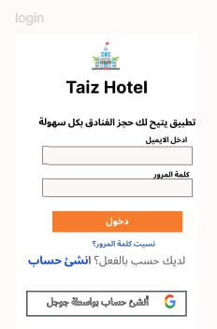
[Insert Image 2: Main Screen Wireframe]
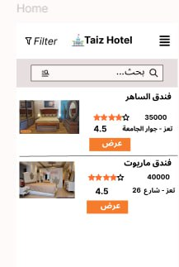
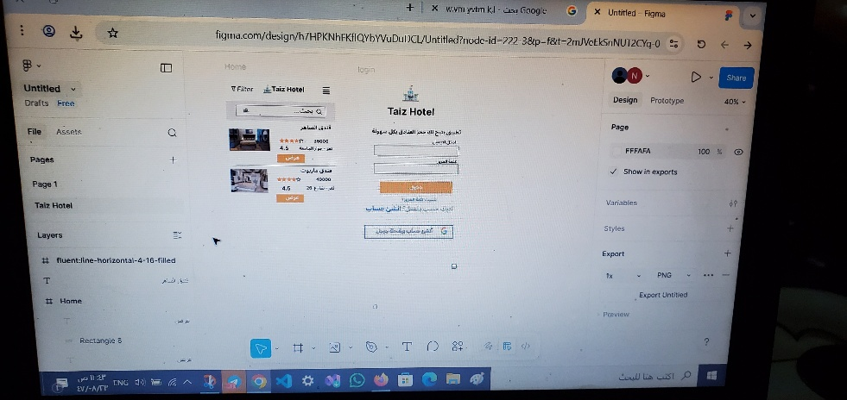

طبعا يا مهندس بالنسبة للتصميم اشتغلت ب الفيجما وهذا مبدئي وهذا رابط الشغل وفيما بعد بيتم شغل كل التطبيق بإذن الله
https://www.figma.com/design/h7HPKNhFKfIQYbYVuDuDCL/Untitled?node-id=222-3

Design Rationale: [A simple and user-friendly layout was chosen to ensure ease of use for users with different levels of technical knowledge, while providing clear navigation and minimal steps to reach the booking feature.]

8. Technical Feasibility Analysis) optional( /

Why Flutter?: [Flutter enables cross-platform development using a single codebase for Android and iOS, offering high performance and flexible UI design.]
Key Libraries/Packages:
- [firebase_core
- firebase_auth
- cloud_firestore
- google_maps_flutter]
Potential Challenges:
- [Limited or unstable internet connectivity
- Maintaining up-to-date hotel data
- Full Arabic language support]

9. Expected Impact /

- [Reduced time required to find and book hotels
- Improved user experience
- Increased accessibility to hotel information
- Support for digital transformation in Yemen’s hotel sector]

